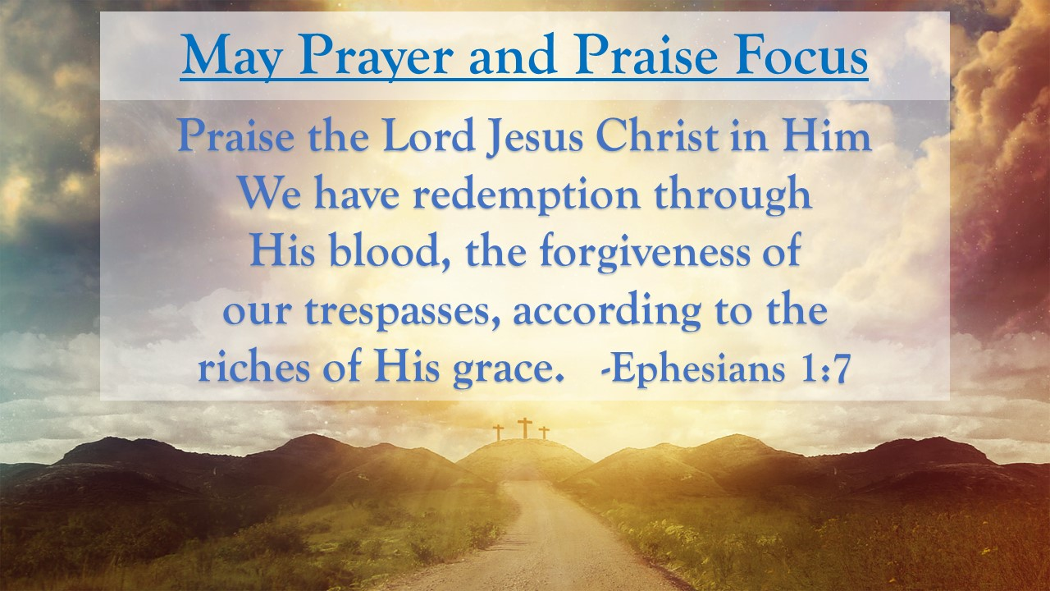
First Baptist News & Info |  |  |  | MAy 10, 2024
Prayer Focus for month:
Ephesians 1:7

Ponder upon this: |  | Furthermore, dear friends, the exceeding riches of God’s grace may be guessed at by the fact that divine mercy is above all our sins. You cannot sin so much as God can forgive. If it comes to a pitched battle between sin and grace, you shall not be so bad as God shall be good. You can only sin as a man, but God can forgive as a God. You sin as a finite creature, but the Lord forgives as the infinite Creator. When I received that thought fairly into my soul last night I felt like Abraham when he laughed for joy: I sin like a man, but he forgives like a God.  ---- Charles Hadon Spurgeon (The Exceeding Riches of Grace – June 1882)

 |  | MAY 10, 2024
Invite a friend, Sign up to help, or join us for the week and let’s have fun learning about God’s rock solid truth in a world of shifting sands.  Attendance/Offerings: May 5 , 2024  - Sunday Morning Worship – 482  - Sunday School – 507  - Online Worship – 49  - Tues/Thurs Bible Studies- 30  - Wednesday – cancelled  - Dickson Health & Rehab Services - 13  - Tithes & Offering Budget: $35,770.39  - Sacred Trust: $270.00  Regular Worship at 9 AM and 10:30 AM in the Sanctuary. The 10:30 AM service will be livestreamed via Facebook and YouTube. Sunday School classes are available for all ages at 8:00 AM (adults only), 9:00 AM (all ages), and 10:30 AM (adults and Preschool only)  Register for Girdiron Men’s Conference: June 14-15 in Huntsville, AL. Registration and information is on the men’s bulletin board & the website. |  | Upcoming Activities  - May 10th – 6 pm to Saturday morning – GA Lock-in  - May 11th – 8 am -10 am – Ladies Fellowship Breakfast  - May 14th – 5-7 pm – PreK/CDC Family Appreciation  - May 20th – 4 pm – Senior Game Night  - May 23rd – 1 pm - Widow’s Fellowship  - May 28th – 30th – Kid’s Sprots Camp  - June 3rd – 7th – 9 am – noon Vacation Bible School
Mid-week Activities: Wednesday, May 15th
- Youth Choir – 5:00 pm in the choir room
- Kids JAM - Children’s Choir – 5:15 pm in the B hallway (End of Year Celebration)
- Fellowship Hall: Pastor’s Bible Study – 6:30pm
- DiscipleLife Classes: 6:30pm, C-Hallway, Guest Central, Youth Building
- Children’s Activities: Children’s Activities: 6:30 pm childcare for birth through ages 3, Mission Friends, RA/GA classes (Pastor Ken Metcalf, Children’s Minister)
- Student Activities: 6:30 pm Conference Center (Pastor Tim Hopper, Student Minister)
- Adult Choir: 6:30 pm (Pastor Jeff Clark)

